$ git init

Initializes the empty git working directory with .git

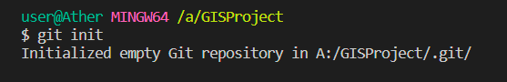

$ git config - - list

Lists all the config

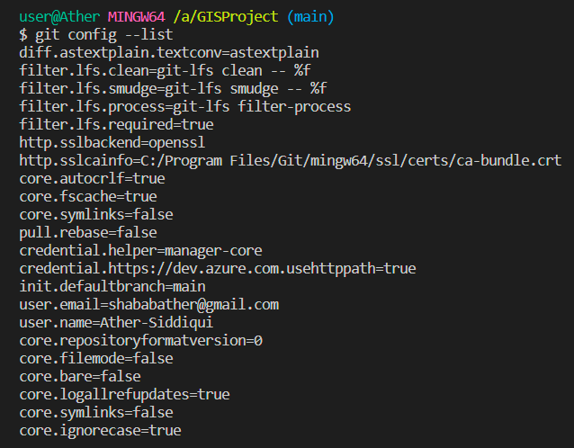

$ git config - - global user.name “Ather-Siddiqui”

Sets the global user name.

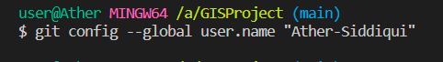

$ git config - - global user.email “[shababather@gmail.com](mailto:shababather@gmail.com)”

Sets the user email



$git status

Lists all the untracked files , not committed files

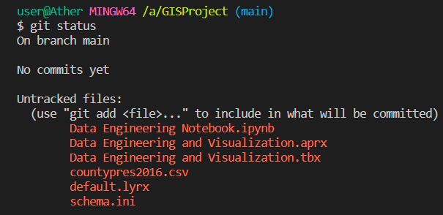

$ git add file1 file 2

Add files file1 and file2 in staging area.



$git add .

Adds all the file to staging area



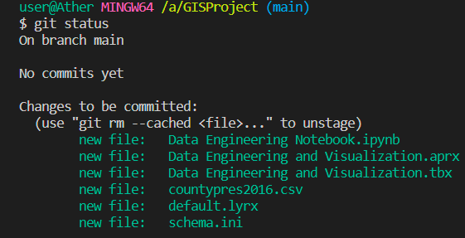

$ git commit –m “commit message”

Commits changes in staging area with commit message

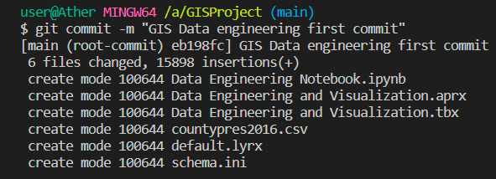

$ git log

To check history of project commits

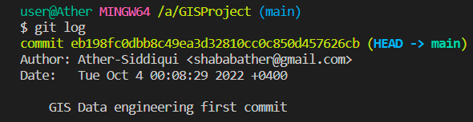

$ git log - -oneline

Provides brief commit info – i.e one commit in one line

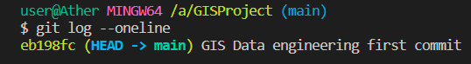

$ git log –p

To see complete difference at each step

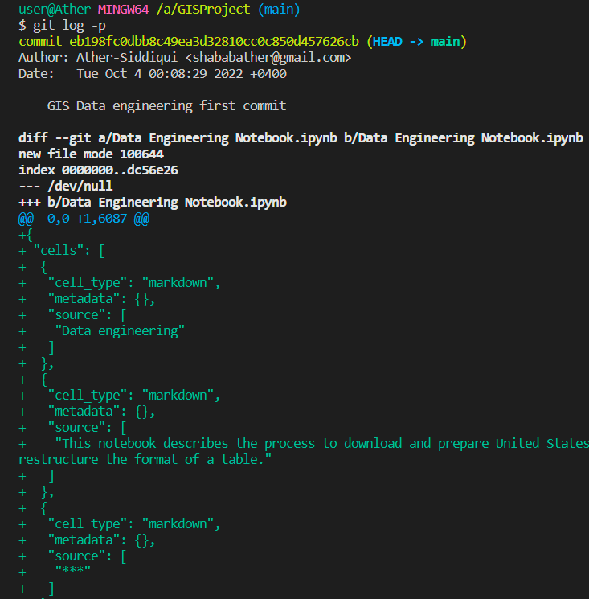

$ git log - - stat and $git log - - stat - - summary

To list overview of the change

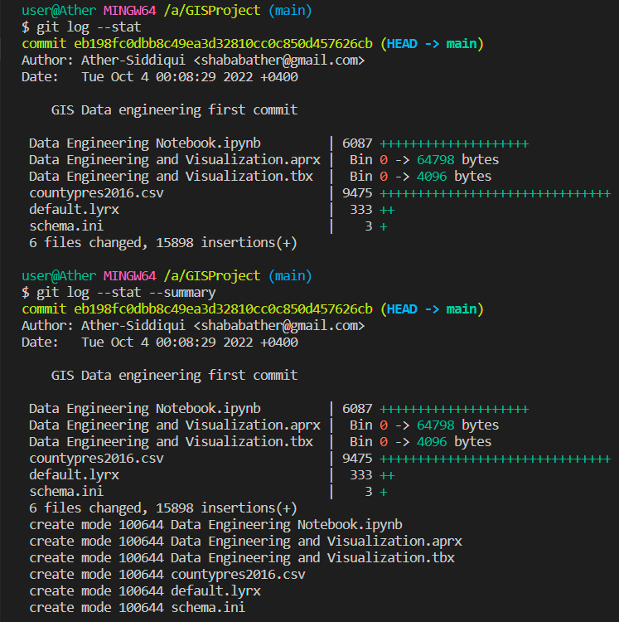

$ git branch Dev

Creates a new branch with branch name as Dev



$ git branch

To list all the available branches

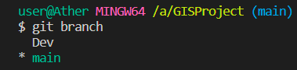

$ git switch Dev

It switches the selected branch to Dev

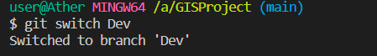

$ git clone “<https://github.com/username/repo.git>”

Clones remote repository into local

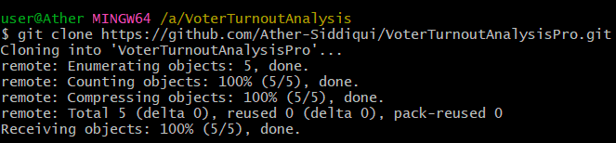

$ git checkout -b “new_branch_name”

Creates a new branch in the local.



Add new file or modify existing file in dataset branch in the local then add it using command and commit using git commit all in dataset branch

$git add .



$ git commit –m “committing changes”



$ git push origin dataset

Push changes to remote dataset branch



Admin or someone will see the pull request created on github. Open the pull request and accept and merge it to main or reject with proper comments.

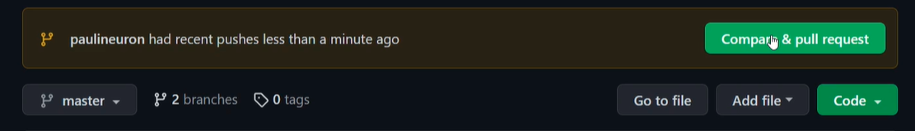

Open review and Merge it to main on git hub remote.

$ git switch main

Switches back to main on the local then ls command. Latest files in remote main after above merge are not present in local.

$ git fetch origin main

$ git merge origin main

Or

$ git pull origin main

Gets the latest changes from remote to the local main

